Modal verb “Can and Coud”  Could you give me money, please?    EXAMPLES:  *You could be wrong.  *This new plan could be very risky.  *I couldn’t watch the T.V. If I don’t do my homework.  *We couldn’t leave you alone.  *Could you open the window?  *Could we go to the stadium on Saturday? | (to ask something)  Can + infinitive (can do / can play / can come etc.):  ? Could + + Verb + comp.?  S. A. Yes, could No, couldn’t
  I/we/you/they/he/she/it |  | Can  Can’t (cannot) |  | Do  Play  See  Come etc.
  Can | I/we/you/they/he/she/it |  | Do?  Play?  See?  Come?
Modal verb “Must, mustn´t and don´t need to”  EXAMPLES:  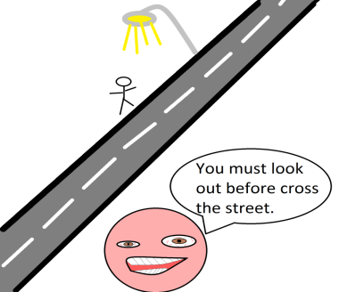  *He must have a lot of money.  *You mustn’t move to London.  *We mustn’t spend the money.  *Must you go to school?  *Must we visit your parents? | (Obligation: rules, prohibitions)  Must + infinitive (must do/ must work etc.):  + + must + verb to + comp.  - + mustn´t + verb + comp.  ? must + + verb + comp.  S.A Yes, must No, mustn´t
  I/We/You/They/He/She/It | Must | Do  Go  See  Eat
Modal verb “ I have to”  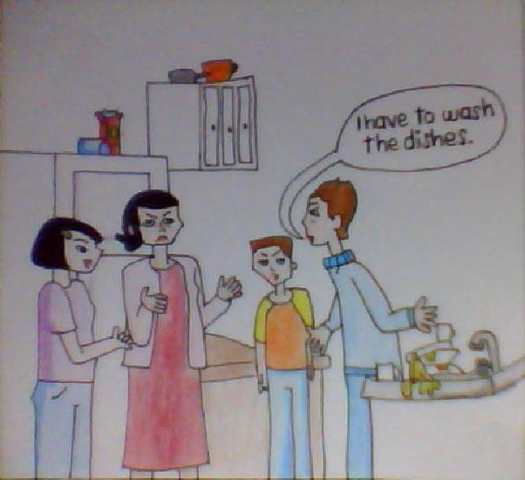  EXAMPLES:  *They have to leave early.  *John has to wear a tie at work.  *You don’t have to eat that.  *Did you have to go to school?  *Do you have to work on Saturday? Yes, I do | (Obligations “persona”)  Present  Past  + + have/has to + verb to + comp.  - + don´t/doesn´t + have to + verb + comp.  ? Do/does + have to + verb + comp.  S.A Yes, have/has to No, don´t/doesn´t have to
  I/ We/ You / They Have | To do  To work  To go
  He/ She / It Has | To do  To work  To go
  Do I / We / You / They | Have to…?
  Does He / She / It | Have to…?
  I / We / You / They Don´t | Have to…
  He / She / It Doesn´t | Have to…
  Did | I / We / You / They  He / She / It |  | Have to…?
  I / We / You / They  He / She / It |  | Didn´t have to…
Modal verb “Should”  I should buy these shoes.  EXAMPLES:  *You should buy some new shoes.  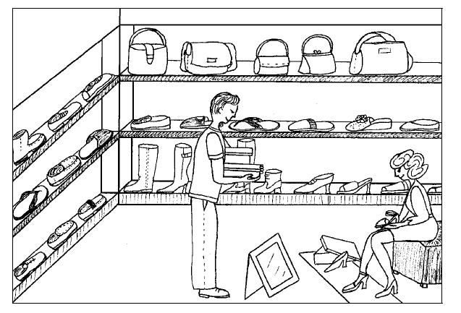  *We should stop car  *what time do you think you should go home?I should 1:00 am | (Recomendation)  Sholud + infinitive  (should do/ should watch etc.):  + + should + verb to + comp.  - + shouldn´t + verb + comp.  ? Should + + verb + comp.  S.A Yes, should No, Shouldn´t
  I/We/You/They  He/She/It | Should  Shouldn´t | Do  Stop

