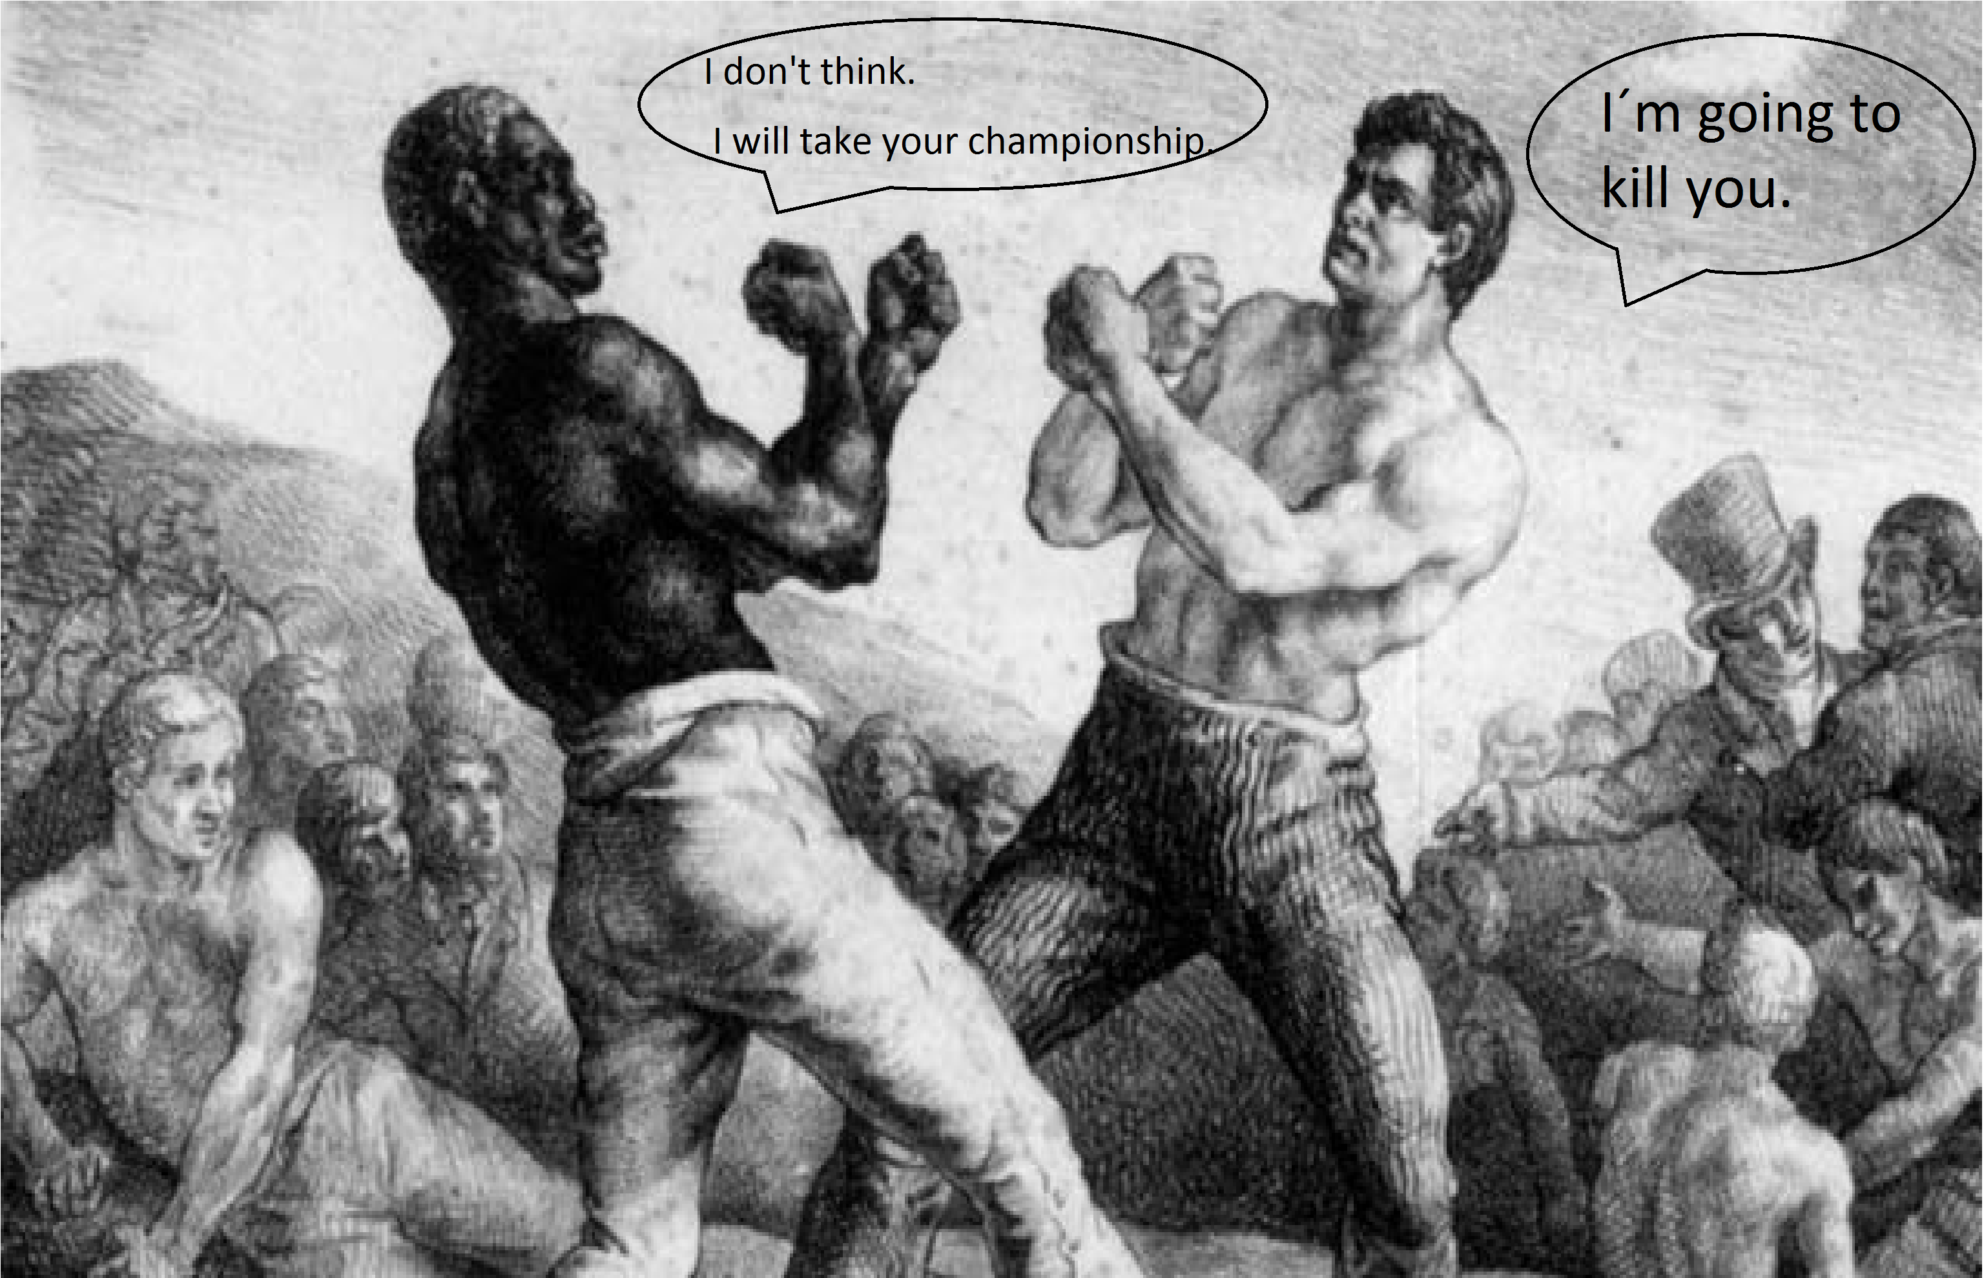
WILL
Will | I/ We/ You/ They  He/She/ It | Be?  Win?  Eat?  Come?  Etc.
+ + will + 1/verb + comp…
I/ We/ You/ They  He/ She/ It | Will (‘ll)  Will not (won’t) | Be  Win  Eat  Come  Etc.
- + will + will + not + 1/verb + comp…
? Will + + 1/verb + comp…+ ?
S.A. Yes + + will No + + won’t
Future Will Predictions
* For the future (Short term decisions).
*I think… will… / I don’t think… I’ll.
*Not use for things we already decided (Long term decisions).
*Offer Something.
*Voluntary actions.

I am  He/ she/ it is  We/ you/ they are | (not) going to | Do….  Drink….  Watch….
GOING TO
Am I  Is he/ she/ it  Are we/ you/ they | Going to | Buy…?  Eat…?  Wear…?
+ + Am/Is/Are + going to + 1/verb + comp...
You can use contractions… (I’m, He’s, We’re, Perla’s)
- + Am/Is/Are + not + going to + 1/verb + comp…
? Am/Is/Are + + going to + 1/verb + comp…?
S.A Yes + + to be No + + not
*For an intention that we decided in past.
*For something is going to happen (prediction) based on evidences.

